AWS Hands-on Lab Guide: AWS WAF and AWS Systems Manager

AWS WAF
Definition: AWS WAF is a web application firewall that protects applications from common web exploits and integrates with ALB, CloudFront, API Gateway and App Runner.
Task 1: Create a Web ACL Step 1: Sign in to AWS.
Step 2: Open AWS WAF & Shield.
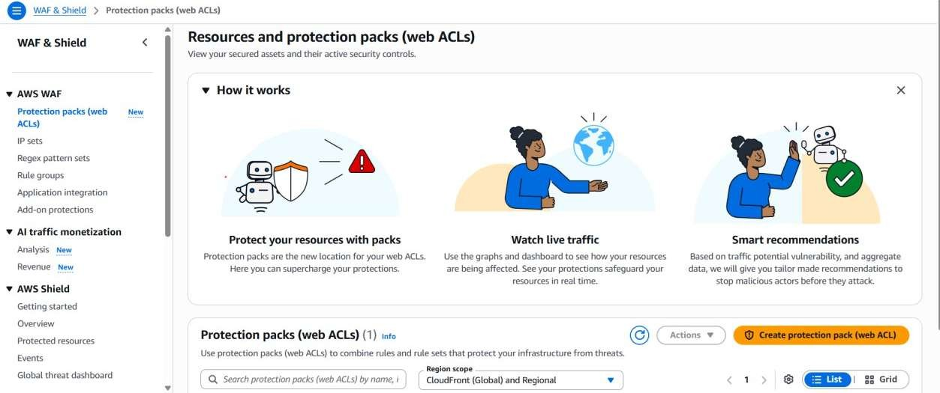
Step 3: Select Web ACLs and click Create web ACL.
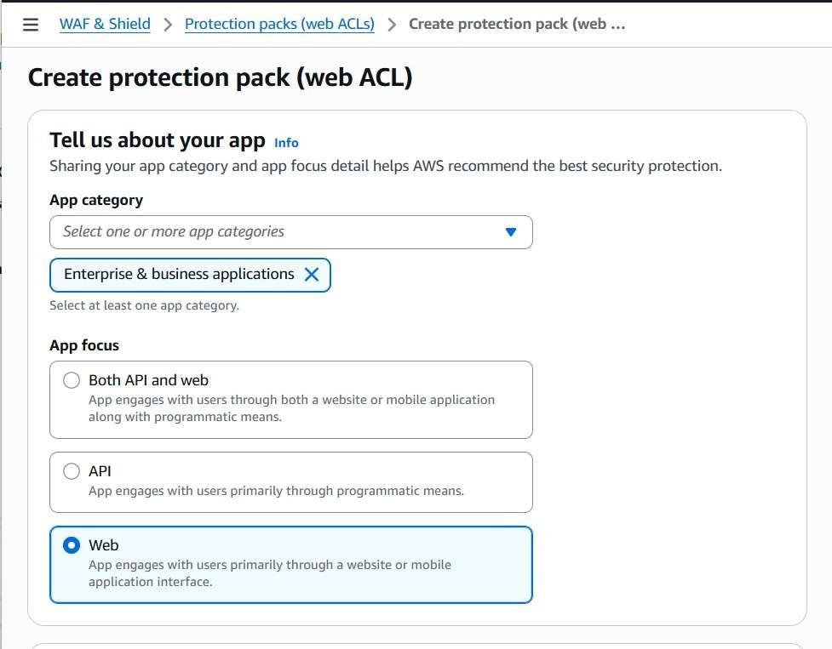

Step 4: Name it MyWebACL.
Step 5: Choose the same Region as your ALB. Step 6: Associate the ALB.
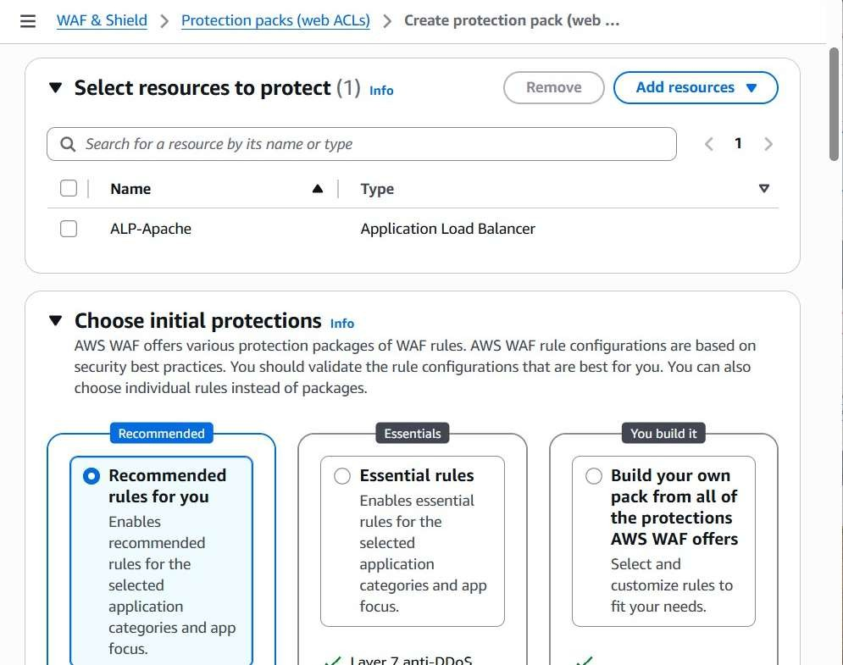

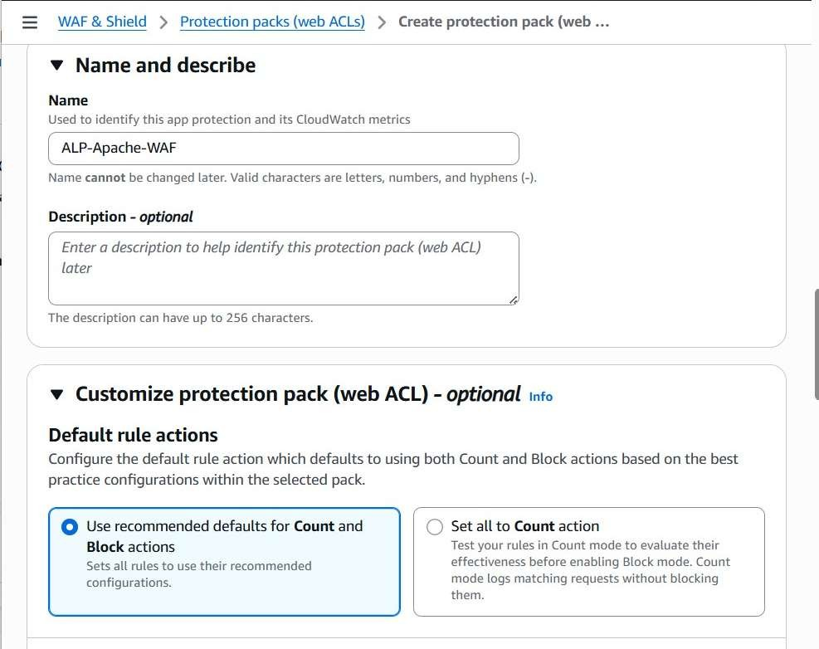
Step 7: Continue and review.

Task 2: Add Managed Rules Step 1: Click Add Rules.
Step 2: Choose AWS Managed Rule Groups.
Step 3: Enable Core Rule Set, Known Bad Inputs, SQL Database, Linux and Anonymous IP rules.
Step 4: Add the rules.
Step 5: Create the Web ACL.

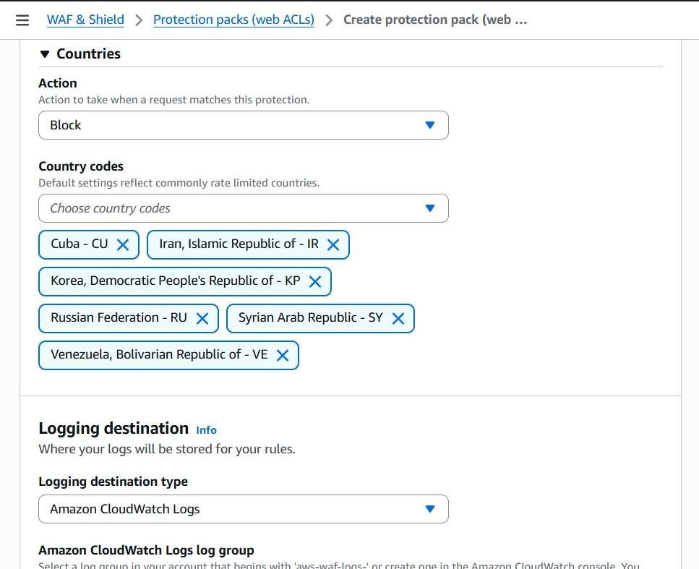
Task 3: Block IP
Step 1: Open the Web ACL.
Step 2: Create an IP Set named BlockedIPs. Step 3: Add IP 203.0.113.25/32.
Step 4: Create a rule using the IP Set. Step 5: Set action to Block.
Step 6: Save.

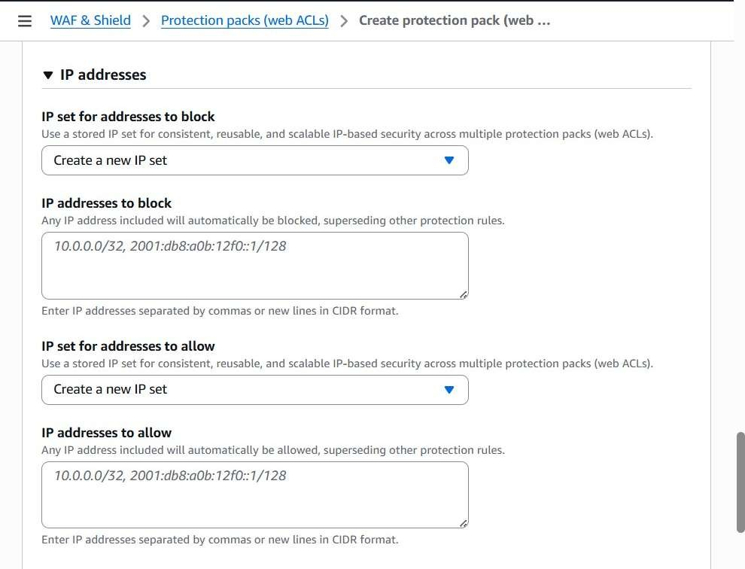

Task 4: Rate Limit
Step 1: Add a Rate-based rule. Step 2: Name it RateLimitRule.
Step 3: Set 1000 requests per 5 minutes. Step 4: Choose Block.
Step 5: Save.

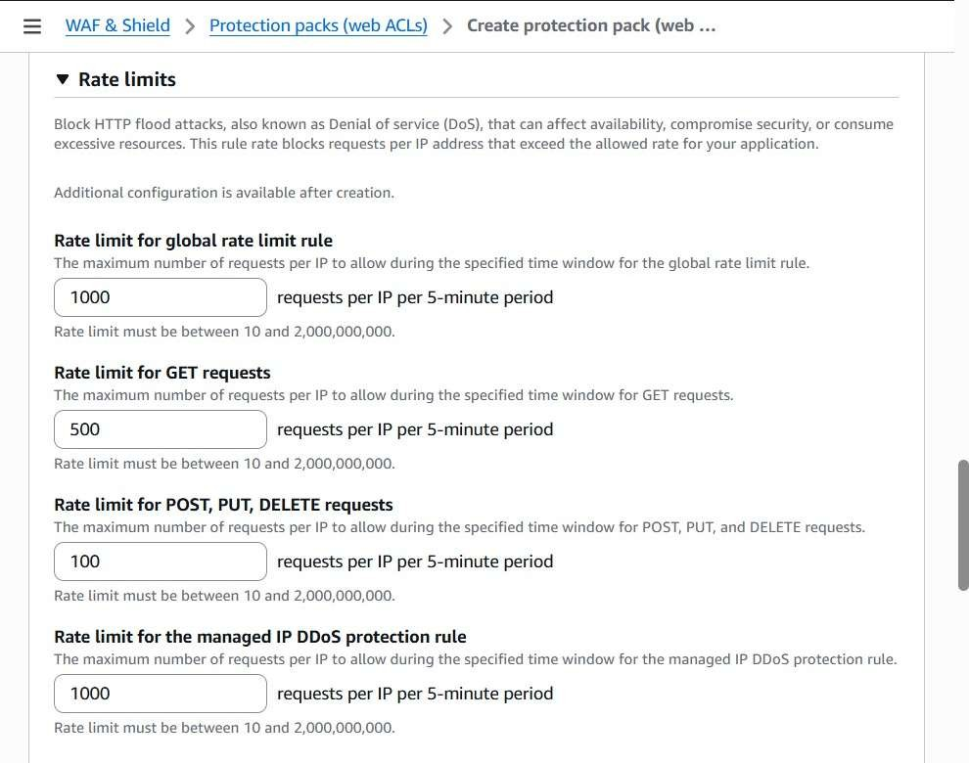

Task 5: Monitor
Step 1: Test using repeated curl requests. Step 2: Verify blocked requests.
Step 3: Open CloudWatch metrics.
Step 4: Create a dashboard for WAF metrics.

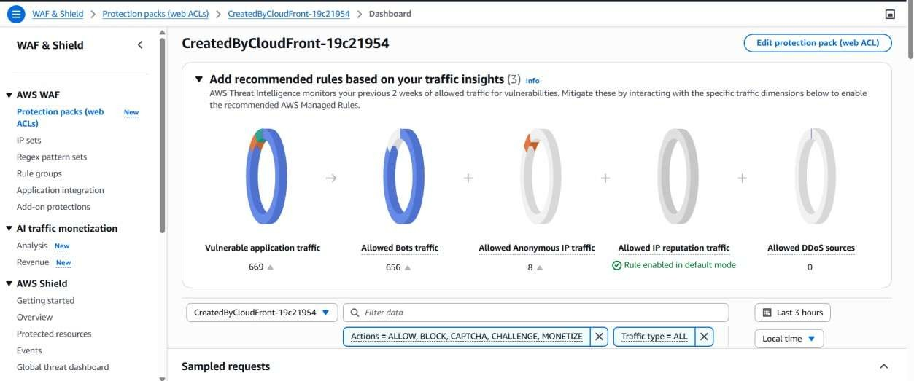

AWS Systems Manager
Definition: AWS Systems Manager securely manages EC2 instances without SSH and provides Session Manager, Run Command, Patch Manager, Inventory, and Parameter Store.
Task 1: Configure Managed Instance Step 1: Launch EC2.
Step 2: Attach AmazonSSMManagedInstanceCore IAM role. Step 3: Verify/start amazon-ssm-agent.
Step 4: Open Managed Nodes and verify Online status.
Task 2: Session Manager
Step 1: Open Session Manager. Step 2: Start Session.
Step 3: Select the instance. Step 4: Run hostname.
Step 5: Exit.
Task 3: Parameter Store
Step 1: Create parameter /Dev/Application/Environment
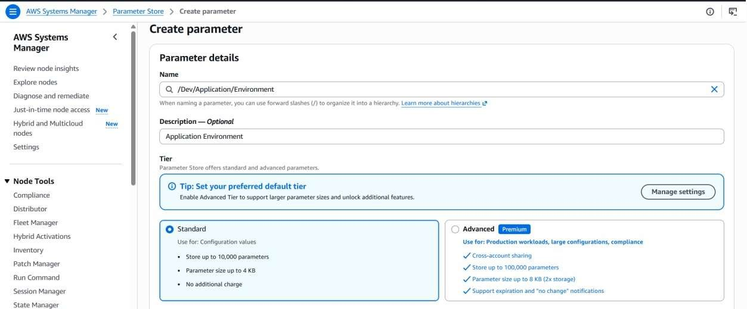

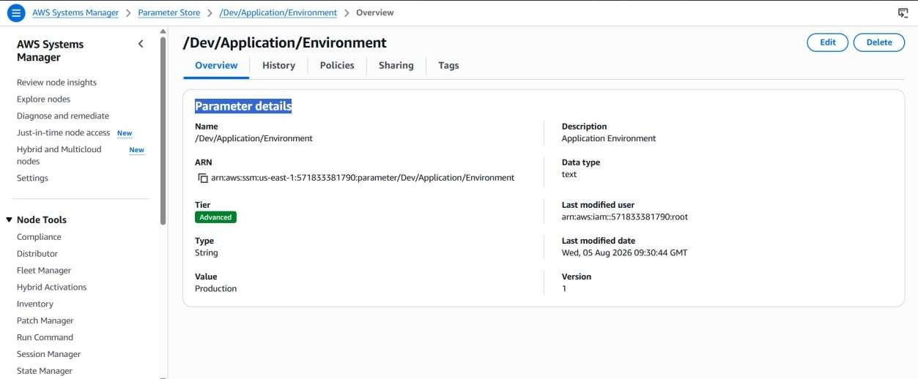
Step 2: Choose String type.

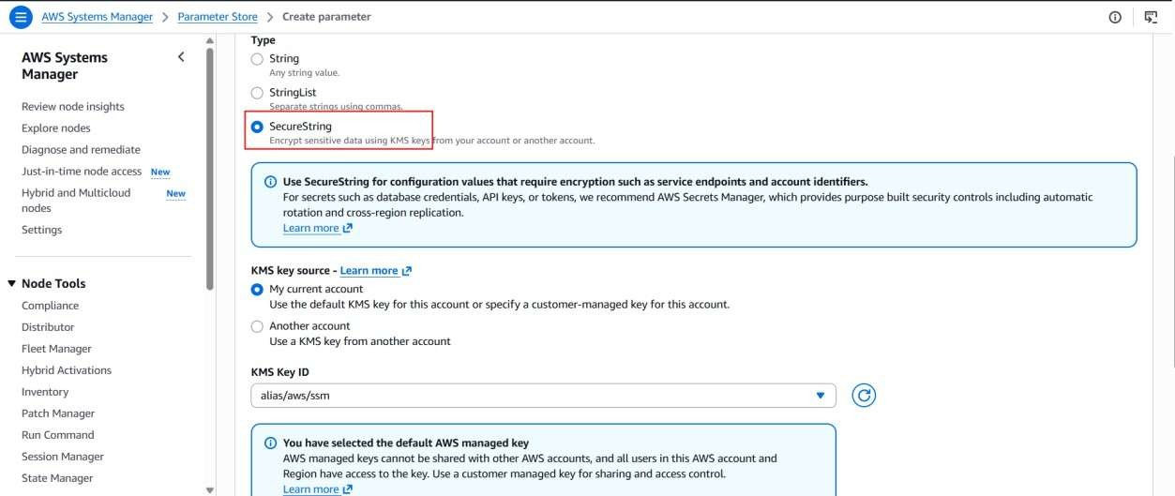

Step 3: Enter value database.example.com.
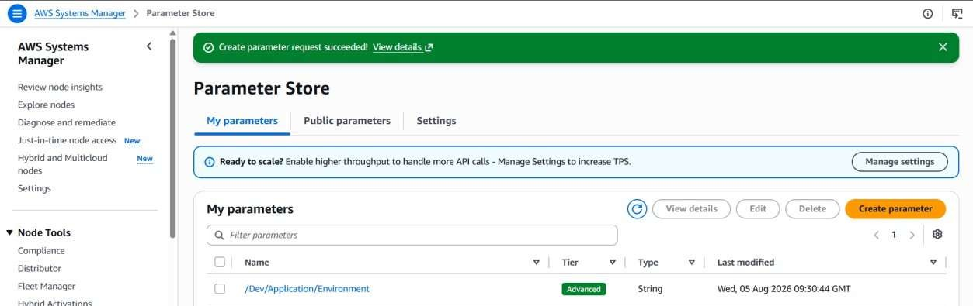

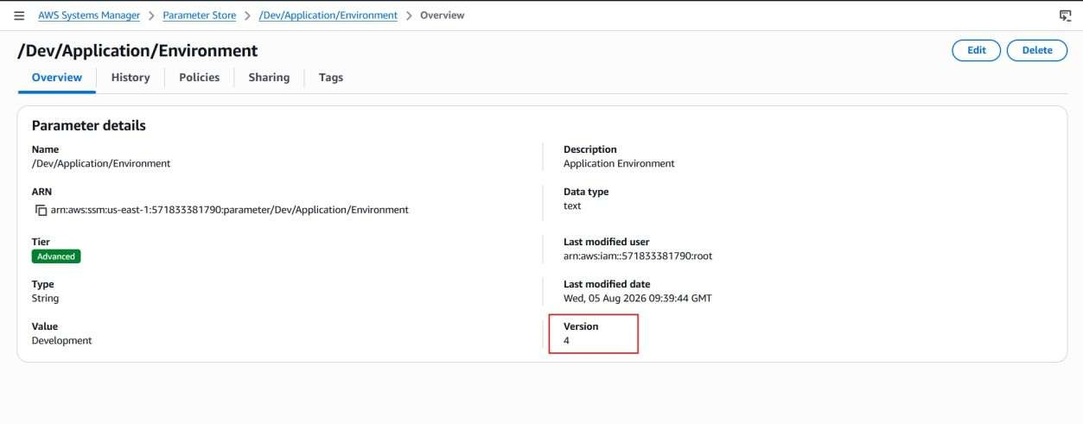
Step 4: Retrieve using aws ssm get-parameter.

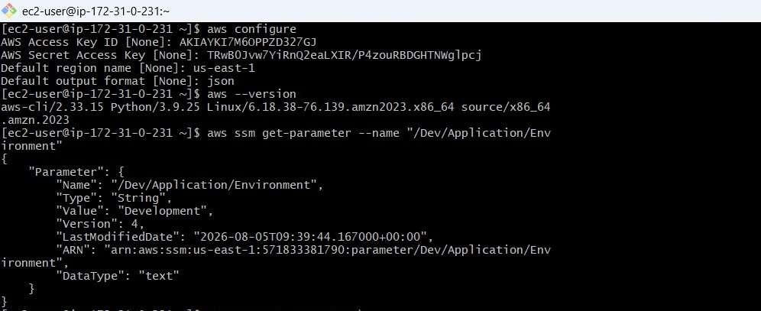

Task 4: Inventory
Step 1: Create inventory association.
Step 2: Collect software and network inventory. Step 3: Review results.
Task 5: Patch Manager Step 1: Choose Patch Now.
Step 2: Select managed instance. Step 3: Run using default baseline. Step 4: Verify patches installed.

